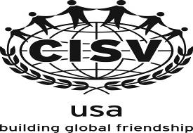
CISV USA’s Privacy Policy

CISV USA, Inc. is committed to respecting the privacy of our donors. We have developed this privacy policy to ensure our donors that donor information will not be shared with any third party. CISV USA provides this Donor Privacy Policy to make you aware of our privacy policy, and to inform you of the way your information is used. We also provide you with the opportunity to remove your name from our mailing list, if you desire to do so. We collect and maintain the following types of donor information: contact information: name, organization, complete address, phone number, email address; payment information: credit card number and expiration date, and billing information; requests to receive periodic updates: e.g., to individuals who request it, we will send periodic mailings and/or e-mails related to specific fund-raising events or appeals, and newsletters.

CISV USA uses your information to complete a transaction, communicate back to you, and update you on organization happenings. Credit card numbers are used only for donation or payment processing and are not retained for other purposes. CISV USA will not sell, rent, or lease your personal information to other organizations. We assure you that the identity of all our donors will be kept confidential. Use of donor information will be limited to the internal purposes of CISV USA. It is our desire to not send unwanted mail to our donors. Please contact us if you wish to be removed from our mailing list or would like to update or review your personal contact information. E-mail communications provide a mechanism to have your address removed from our contact list.
If you have comments or questions about our donor privacy policy, please send us an email at cisvusa@cisvusa.org or call us at 513.674.9242.

